**The SSE Arena, Belfast Theatre Information**

The information included here will assist in determining what is achievable technically for your event. Please read thoroughly and discuss any of your technical needs with the Operations Department.

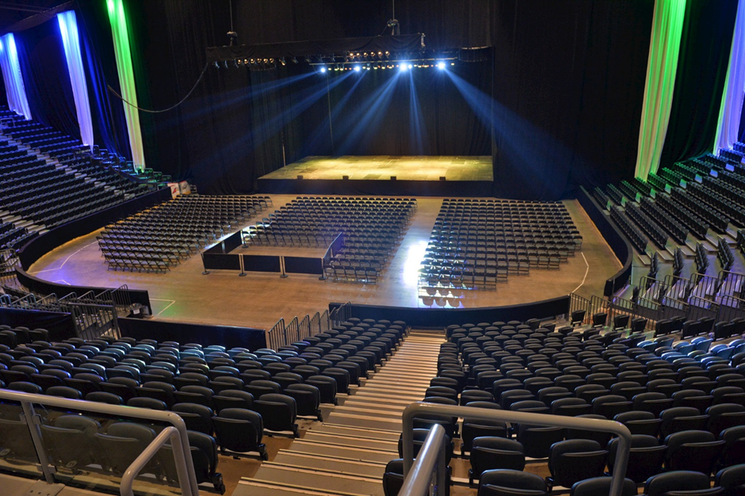

**General**

The Theatre is situated in the Main Auditorium and is on the ground floor level. The auditorium is draped to give the theatre feel with all the dead space behind the stage masked. The Theatre size can be increased and decreased to suit your event and your required capacity.

Please click on the below link to see our theatre set up in action!

<https://youtu.be/28mF9nNANTA>

**Seating**

The audience entrances is at the rear of the auditorium on the ground floor or via the vomitories on the first floor. The rows of floor seating are all set on the one level and are not raked. The tiered seating rows are raked. Suites may be used on the second floor depending on the sightlines for your event.

**Performance Space**

The house stage is a Stage Right ME3750 stage with standard dimensions of 60ft x 40ft. The stage height can vary from 4ft – 6ft (by 2 inches at a time). Increases or decreases to the stage size are possible depending on availability of staging. Additional staging can be sourced locally and paid for by the event organiser if required. The house stage is built in 8ft x 4ft sections and is finished in a matt black colour.

Max footprint including wings / walkways is 84ft wide due to mandatory fire lanes.

It is not permissible to fix into the stage, floor or any walls at the venue.

Entrances to the stage can be agreed in advance via 4x sets of stage treads or a stage ramp.

All fire exits must remain clear and visible to the audience. The Duty Manager or Technical Manager will confirm the exits prior to your event commencing.

**Theatre Drape**

As part of any contract, in a theatre format, the venue will provide draping to create a complete black wall and box the stage which will completely mask all backstage areas. The draped areas include:

• Upstage Edge of Stage

• Side Drapes for side of stage to box in

• Proscenium Arch with side extensions

• Side Drapes to join at the Proscenium Arch and to run into the tiered seating

N.B. The venue does not hold any drapes in house for flat draping seats / unsold areas.

If your event requires a specifically draped format or additions / removals of any of the above areas please confirm in advance with the Venue Operations Department when setting the event up for on sale.

If you r event exceeds the initial ticketed set up the format can be easily extended. Our roof mounted track system helps to facilitate easy movement and quick turnaround times.

**Sightlines for Theatre Shows**

The venue has a generic sightline degree which has been used for other shows. A good sightline is taken as 74˚ from USC and a possible restricted view from 112˚ centre stage to 74˚ at USC. Whilst it is generally a good guide it is dependent on Production elements (such as: video screens, number of performers on stage, set etc).

It is recommended that the Production / Management of the event / Artist confirms with the Venue Operations Department what the normal sightline is for their show before on sale to reduce the likelihood of sightline issues.



**Get In**

We load in all shows through the acoustic doors from the service yard. This is situated at the east end of the venue, is upstage of the main stage and is at the same level as the main auditorium. There are two usable doors which measure 3.6m (w) x 5.3m (h) and 7.1m (w) x 5.3m (h). Alternative areas for loading in and out can be discussed with the Duty Manager.

House forklift trucks can be hired at a cost of £100 per 4 our call and £25 per hour thereafter. The trucks must be driven by Arena licenced and insured personnel. There are 3x house forklift trucks available with lifting capacities of 3Tn, 2.5Tn and 2Tn respectively.

**Control Position**

The control position is situated at the rear of the flat floor behind the seating. It has clear view of the stage and can be raised on platforms if required. A Clearcom intercom patch can be easily reached from this location to tie into the house coms system. All cable runs to the control position must run inside the dasher, between dasher and Row A, up and over emergency exits and across the main floor in house DDA cable ramps. No cables can run through emergency exits.

**Dressing Rooms**

There are 9 multipurpose dressing rooms accessible of stage right plus 3 locker rooms. They can accommodate a different number of people and can be used as offices, dressing or warm-up rooms. The majority of rooms have a toilet and shower facility. A key pad lock system can be used on each of these rooms to secure valuables in.

**Laundry**

We are able to offer laundry facilities with 2x large load washers and driers.

**Power**

Stage Right 1200amp (max) TPN powerlock

Stage Left 800amp (max) TPN powerlock

Centre Roof 2 x 200amp TPN powerlock

Outside Broadcast 200amp TPN powerlock

Rear Service Yard 200amp (max) TPN ceeform

Camera/Follow spot 32amp TPN & 63 amp TPN

**Lighting Equipment Specification**

The venue are currently not able to offer an in-house lighting package or equipment to hang lighting from. All lighting must be hired in with independent motors and trussing also provided. Local production contacts can be found at the end of this document.

Walk-in lighting is normally provided by the venue and is instantaneous halogen flood lighting set at an agreed level by the Duty Manager and Technical Manager in agreement with Production.

**Followspots**

The venue currently has 4x 2K Xenon Supertroopers in house. These can be rented at a cost of £50 per spot per day. Crew can be provided by the house at an agreed rate however it is preferred that Production included crew as part of their load in or show call.

**Sound Equipment Specifications**

As the event organiser you can bring your own sound system to the venue.

The venue currently has a house L-Acoustics ARCS speaker system which is configured as:

* 10x ARCS flown left and right as 5 over 5
* 3x SB218 sub bass loudspeakers
* 5x dV-DOSC or similar as ground fill
* Optional flown delay cluster of 4x ARCS
* Amplifiers are Lab Gruppen PLM 10,000Q

XLR connections are provided for left and right with delay and fills level controlled from tablet.

If you have any additional PA requirements the venue is not contracted to any production company but we can recommend contacting the company below who have extensive experience of working with the venue and the house PA.

PHG Production House

John Willis or Steven Montgomery

[ssearena@productionhouse.net](mailto:ssearena@productionhouse.net)

+44 (0) 2890 798999

**AV Equipment Specifications**

The venue are currently not able to offer an in-house video package or equipment to hang video equipment from. All video equipment must be hired in with independent motors and trussing also provided. Local production contacts can be found at the end of this document.

**Rigging**

Rigging plans should be submitted to the Operations department for approval.

Roof specifically designed to accommodate large touring productions.

Riggers to hang equipment should form part of the hire for any lighting/sound or PA packages for your event. The only exception to this is if the house PA is being used whereby the house will ensure all house PA is properly hung and supply our own riggers for this. If your event has bridles or more than 12 dead-hangs it is expected that there are at least 2x up-riggers. Local contacts for riggers can be found at the end of this document.

The venue will provide 1x House Rigger who is responsible for overseeing all the rigging work taking place in the building to ensure it is hung safely and correctly. The House Rigger is on site for rope rescue if there are any difficulties experience in the roof by production riggers.

**Technical Support**

If your event requires any lighting, sound or video you will need to provide your own technician. The venue can suggest local technicians who may be hired in at the event organisers cost if required.

Crew for assisting with load in, stage hands or load out is not included as part of the Arena contractual agreement. As event organiser you are able to bring in your own preferred crew. The crew should bring their own PPE (Hard Hats, Steel Toe Capped Boots and Hi-Viz Vests) as the venue does not provide these. Local contacts for crew can be found at the end of this document.

**Security**

Included in theatre rentals are all front of house staff e.g. stewards, ticket takers, medics, safety officers, merchandise, F&B units.

The hirer only needs to provide back stage security.  For your type and size of event this should be minimal.  Local contacts for security can be found at the end of this document.

**Storage**

Please leave the space as you find it. There may be an event following yours in the venue therefore it is important that you remove all of your belongings promptly as agreed contractually. There is very limited provision even for the short term storage of items.

**PRS**

PRS will be deducted at settlement. Please inform us which rate is applicable.

**Catering**

As part of the rental you have use of crew catering facilities & dining room back-stage.

You can bring in your own caterers to cook/provide the food.

If you wish, our in-house catering department can provide catering services and give you a quotation based on your requirements. If you would like to use our caterers please discuss with the Duty Manager in the first instance.

**Additional Needs**

We understand the importance of flexibility and if the demands of your event exceed the facilities we offer we will do our utmost to accommodate them. This may of course require the hiring of extra equipment or additional technical time, which may incur extra costs. Please ensure that you discuss these details with the Duty or Technical Manager.

**Venue Contacts**

Duty / Event Manager – David Lamont – [david.lamont@ssearenabelfast.com](mailto:david.lamont@ssearenabelfast.com) - +44 (0) 7435 762915

Duty / Event Manager – Lisa McAnally – [lisa.mcanally@ssearenabelfast.com](mailto:lisa.mcanally@ssearenabelfast.com) - +44 (0)7856 742811

Technical Manager – Brian Campbell – [brian.campbell@ssearenabelfast.com](mailto:brian.campbell@ssearenabelfast.com) – +44 (0) 7720 555632

**Local Contacts**

**Crew**

Show Inc UK

Contact: Turlough McShane, [turlough@turloughmcshane.com](mailto:turlough@turloughmcshane.com), +44 (0) 7778 369419

Aiken Promotions

Contact via Local Promoter Rep: John McGuigan, [john@aikenpromotions.com](mailto:john@aikenpromotions.com), +44 (0)7778 255655

Stage Crew

Main Contact: Damien Cullinan, +44 (0) 2890 329897 or +44 (0) 7711 885164

**Rigging**

Production Service Ireland

Contact: Sean Pagel, [sean@productionireland.com](mailto:sean@productionireland.com), +44 (0) 7727 178028

**Catering**

Alchemy

Contact: Tony Liddell, [tony@alchemyevents.net](mailto:tony@alchemyevents.net), +44 (0) 7909 968383

Leo Nolan

Contact: [leonolan07@eircom.net](mailto:leonolan07@eircom.net)

**Security**

Eventsec

Contact: Kelly Baillie, [generalmanager@eventsec.co.uk](mailto:generalmanager@eventsec.co.uk), +44 (0) 28 90766084

**Production Companies**

Production House Group

Contact: John Willis, [john@productionhouse.net](mailto:john@productionhouse.net), +44 (0) 7787 150606

Production Services Ireland

Contact: Sean Pagel, [sean@productionireland.com](mailto:sean@productionireland.com), +44 (0) 7727 178028